**Task 1: using models, we create a database scheme**

|  |  |  |  |  |
| --- | --- | --- | --- | --- |
| **ID** | **Title** | **Authors** | **Price** | **Edition** |
| 1 | Continuous Delivery | J.Humble and D. Farley | 120.00 | 3 |
| 2 | Reversing: Secrets of Reverse Engineer | E. Eilam | 97.00 | 2 |
| 3 | The Hundred-Page Machine Learning Book | Andriy Burkov | 100.00 | 4 |

**Step 1:** 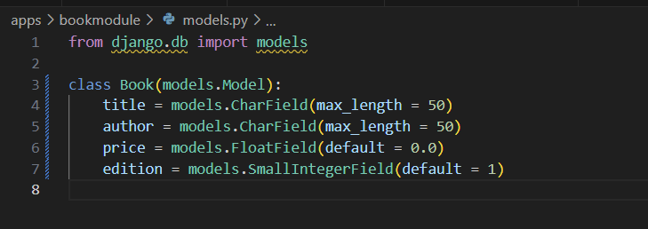

**Step 2:** 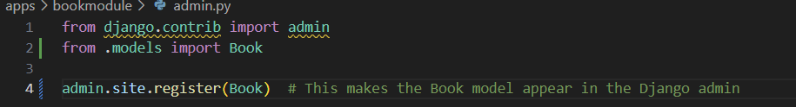

**Task 2: use the application ‘DB Browser for SQLite’ or ‘VS code’ to view the database and insert fake data into it.**

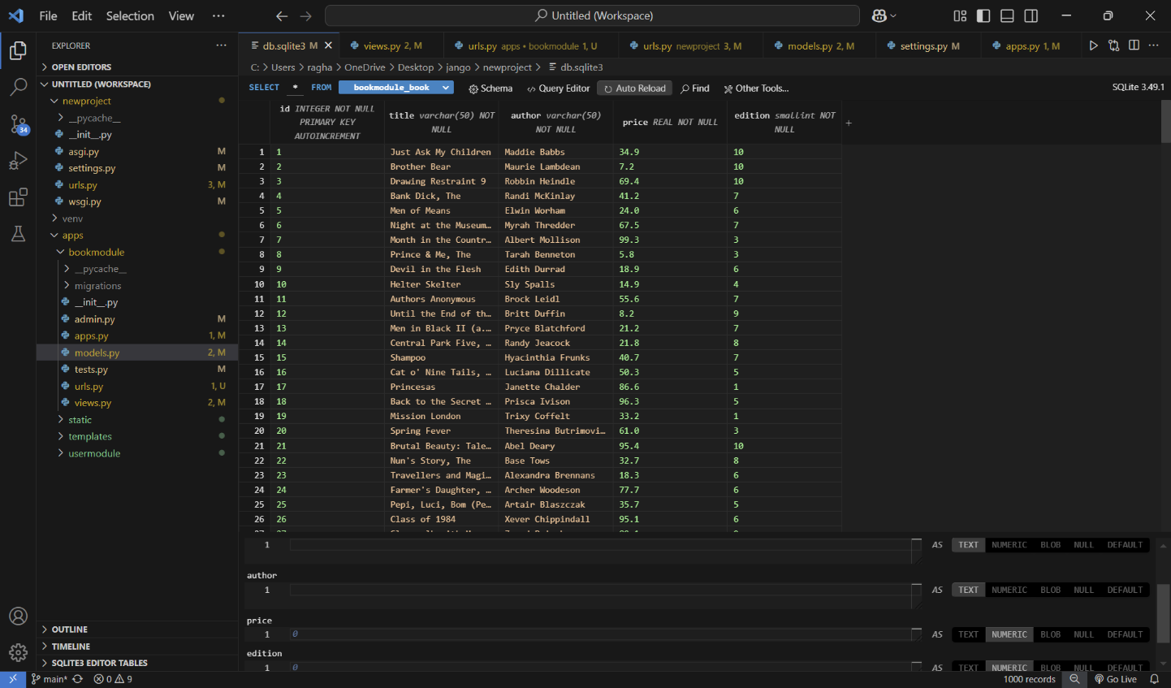

**Step 4:** 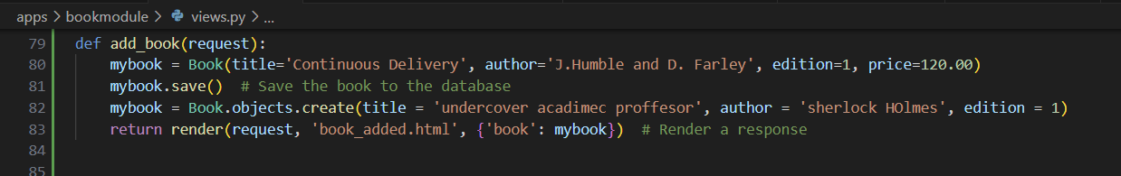

**Task 3: Use simple queries using Django ORM.**

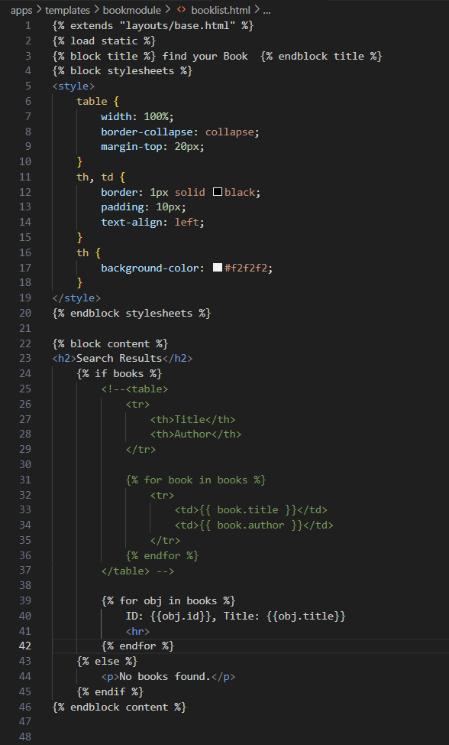

**Step 4:** 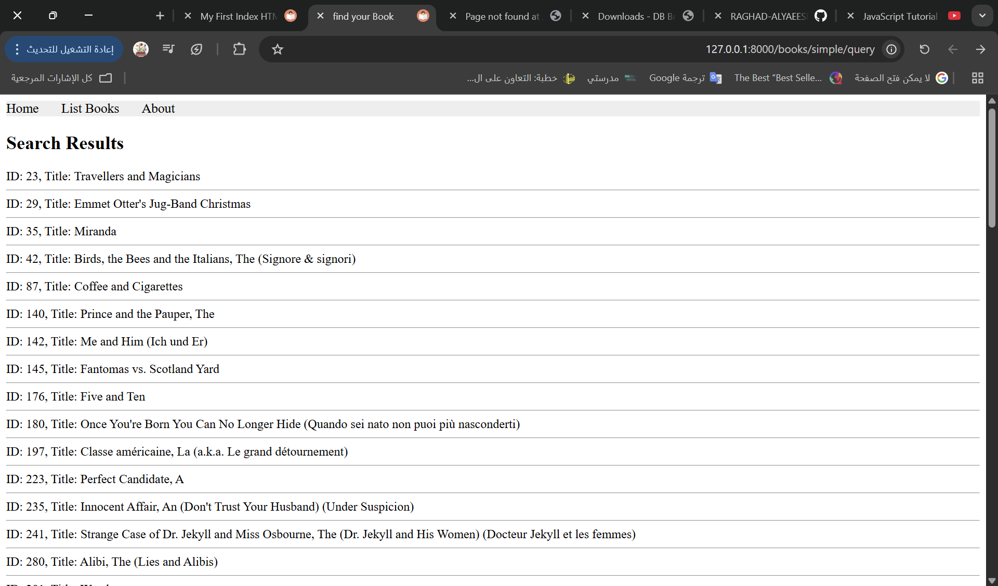

**Task 4: Customize queries using common lookup conditions and keywords.**

**Step 1:** Create URL ‘/books/complex/query’ with a view function ‘lookup_query’ in ‘apps/bookmodule/views.py’:

